Zoo Scavenger Hunt

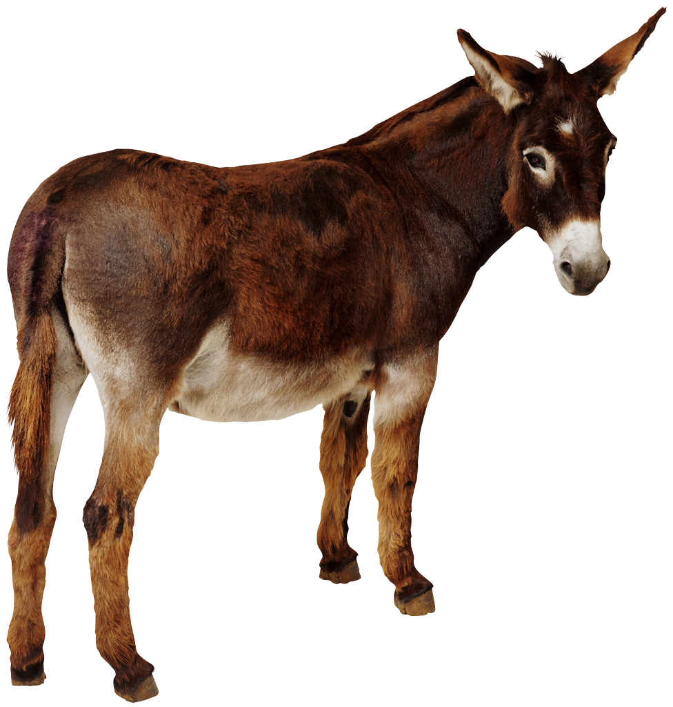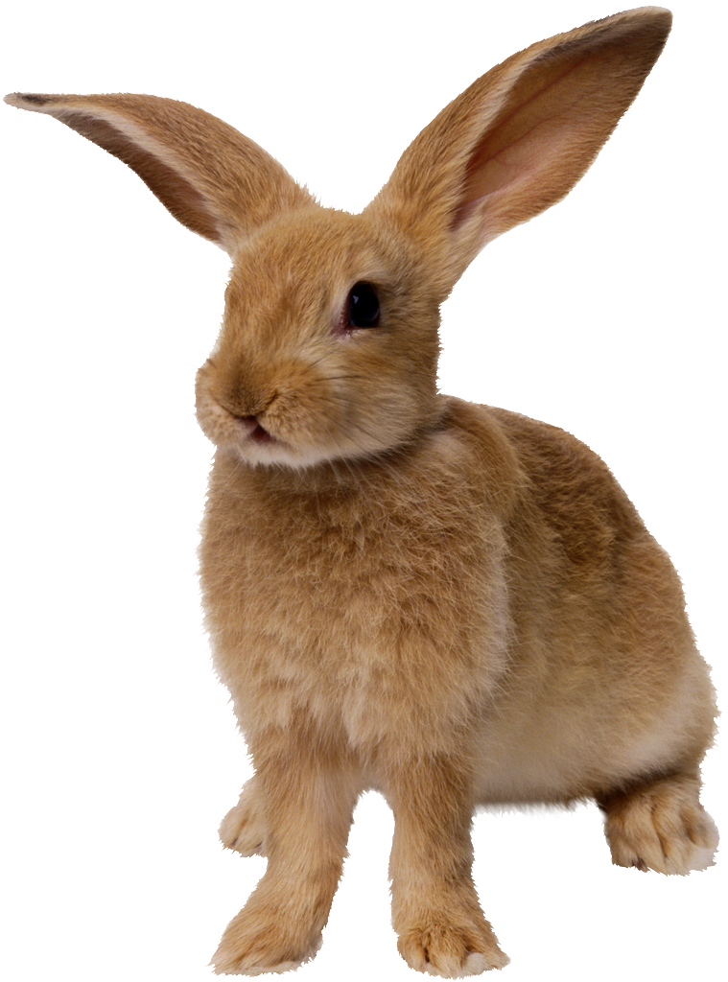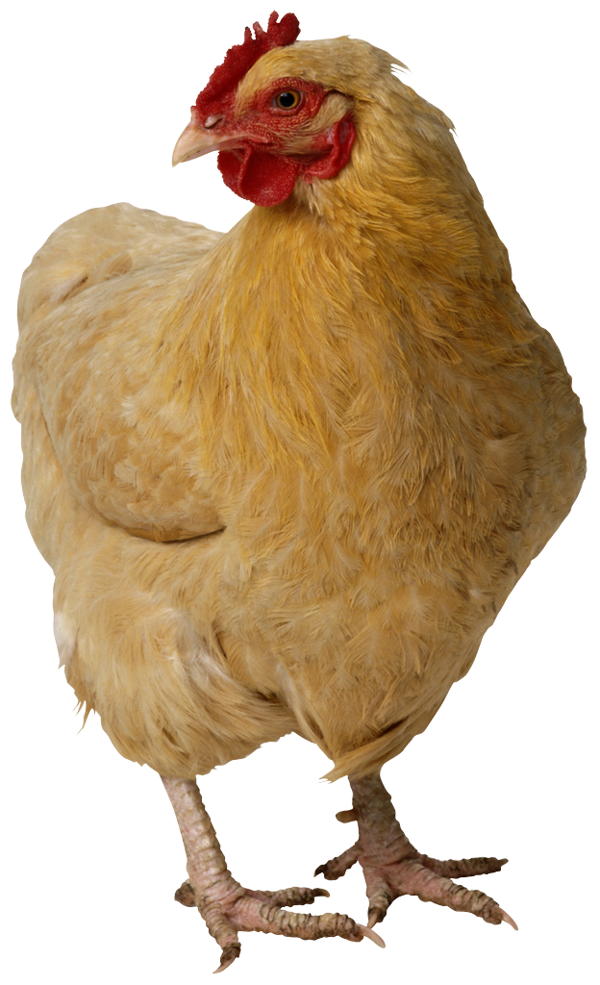

Small Primate Large Feline

Water Mammal Reptile

Beatle Red Flower

Squirrel Maple Leaf

Pick up Litter flightless bird

Animal you would like to be

Animal you would like as a pet

Animal that could climb a mountain

Zoo Scavenger Hunt

Small Primate Large Feline

Water Mammal Reptile

Beatle Red Flower

Squirrel Maple Leaf

Pick up Litter flightless bird

Animal you would like to be

Animal you would like as a pet

Animal that could climb a mountain

